Image | 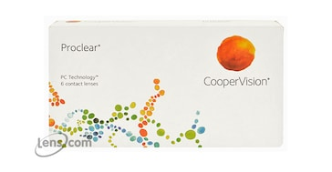
Brand | MICHEAL KORS
Model Name | COPPER VISION
Price | RS 1200
PRODUCT DETAILS

